# Experiment – 09

# Study of 5G Handover procedure (Level 2)

## Objective

In this experiment, we will study the procedure of handovers in 5G networks in more details. We will study the following aspects through Netsim **v13.3**:

1. The process of handover signaling via packet analysis through the RAN and core-network.
2. The impact of handover on the delay and throughput of the UE under handover.

## Introduction

The handover logic of NetSim 5G library is based on the Strongest Adjacent Cell Handover Algorithm[1]. The algorithm enables each UE to connect to that gNB which provides the highest Reference Signal Received Power (RSRP). Therefore, a handover occurs when a better gNB (adjacent cell has offset stronger RSRP, measured as SNR in NetSim) is detected.

Netsim implements a handover procedure similar to that described in 3GPP TS 38.331, Sec. 5.5.4.4, Event A3, wherein a handover occurs when a Neighbor cell’s RSRP becomes Offset better than serving cell’s RSRP. Note that in NetSim report-type is periodic, not event Triggered, since NetSim is a discrete event simulator, not a continuous time simulator.

This algorithm is susceptible to ping-pong handovers; continuous handovers between the serving and adjacent cells on account of changes in RSRP due mobility and shadow-fading. At one instant the adjacent cell's RSRP could be higher and the very next it could be the original serving cell's RSRP, and so on.

To solve this problem the algorithm uses:

1. Hysteresis (Hand-over-margin, HOM) which adds a RSRP threshold (Adjacent_cell_RSRP - Serving_cell_RSRP > Hand-over-margin, or hysteresis), and
2. Time-to-trigger (TTT) which adds a time threshold.

This HOM is part of NetSim implementation while TTT can be implemented as a custom project in NetSim. The reader is requested to refer to experiment – 7 for a discussion on the process of handovers and related theory from the PHY viewpoint.

## Network Setup

Open NetSim and click on **Experiments> 5G NR> Handover in 5GNR> Handover Algorithm** then click on the tile in the middle panel to load the example as shown in Figure 0‑1. In the next section, Select the Throughput and delay variation in the handover column: Effect of handover on Delay and Throughput.

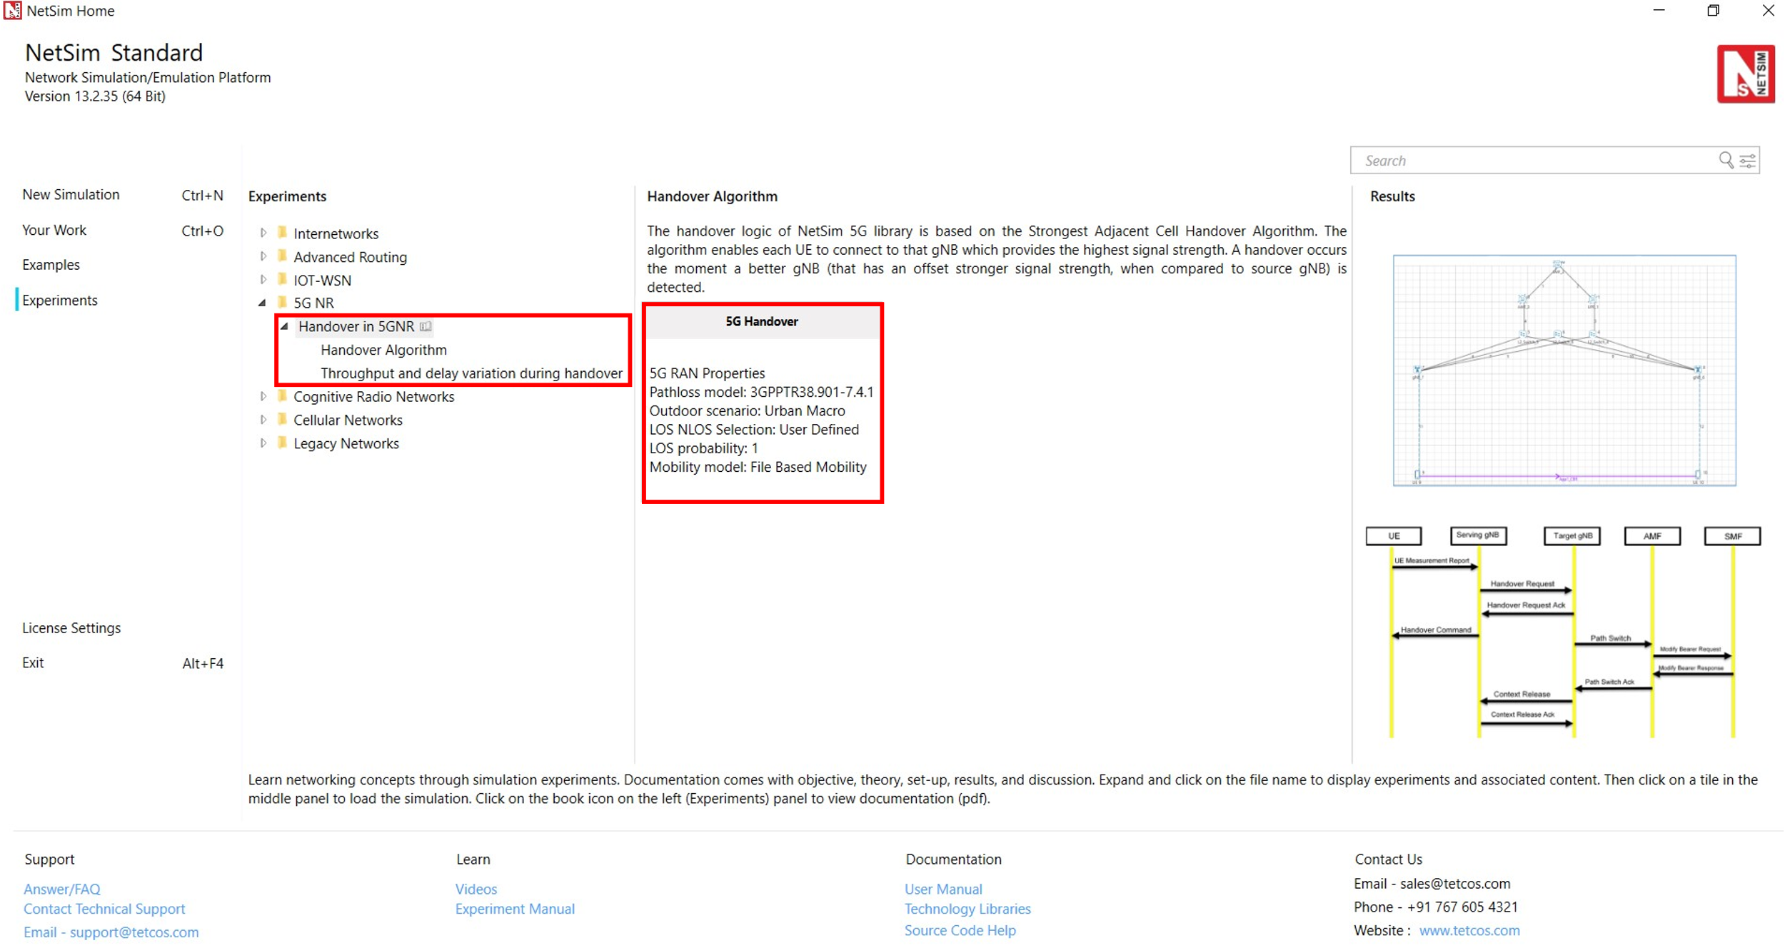

Figure 0‑1: List of scenarios for the example of Handover in 5GNR

## PART I: HANDOVER ALGORITHM

The Netsim UI displays the network configuration for this experiment as shown in Figure 0‑2.

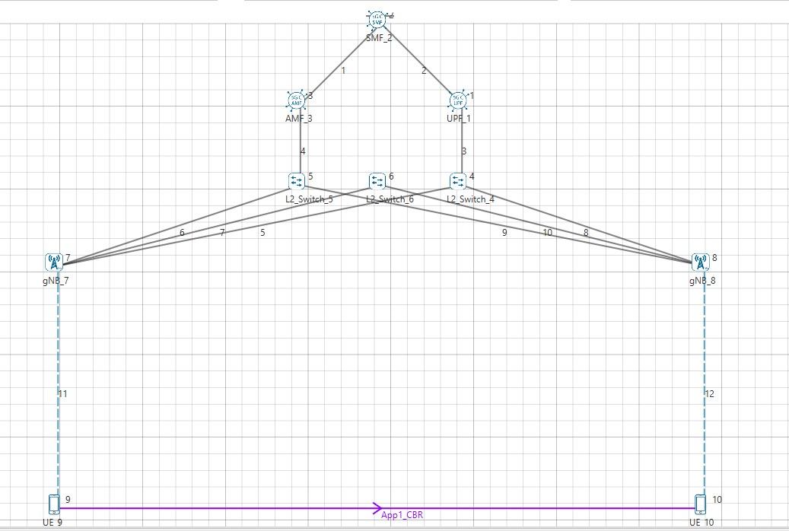

Figure 0‑2: Network set up for studying the 5G handover

### Procedure for 5G Handover

The following set of procedures were done to generate this sample:

**Step 1:** A network scenario is designed in NetSim GUI comprising of 5G-Core, 2 gNBs, and 2 UEs in the **“5G NR”** Network Library.

**Step 2:** The device positions are set as per the table given below Table 0‑1.

|  |  |  |  |  |
| --- | --- | --- | --- | --- |
|  | gNB 7 | gNB 8 | UE 9 | UE 10 |
| X Co-ordinate | 500 | 4500 | 500 | 4500 |
| Y Co-ordinate | 1500 | 1500 | 3000 | 3000 |

Table 0‑1: Device positions

**Step 3:** In the General Properties of UE 9 and UE 10, set Mobility Model as File Based Mobility.

**Step 4:** Right click on the gNB_7 and select Properties, the following is set Table 0‑2.

|  |  |
| --- | --- |
| Interface_4(5G_RAN) Properties | |
| CA_Type | Single Band |
| CA_Configuration | n78 |
| CA_Count | 1 |
| Numerology | 0 |
| Channel Bandwidth (MHz) | 10 |
| PRB Count | 52 |
| MCS Table | QAM64 |
| CQI Table | Table 1 |
| X_Overhead | XOH0 |
| DL UL Ratio | 4:1 |
| Pathloss Model | 3GPPTR38.901-7.4.1 |
| Outdoor Scenario | Urban Macro |
| LOS_NLOS_Selection | User_Defined |
| LOS Probability | 1 |
| Shadow Fading Model | None |
| Fading _and_Beamforming | NO_FADING_MIMO_UNIT_GAIN |
| O2I Building Penetration Model | LOW_LOSS_MODEL |
| Additional Loss Model | None |

Table 0‑2:gNB_7 > 5G_RAN Interface Properties Window

Similarly, it is set for gNB 8.

**Step 5:** The Tx_Antenna_Count was set to 2 and Rx_Antenna_Count was set to 1 in gNB > Interface (5G_RAN) > Physical Layer.

**Step 6:** The Tx_Antenna_Count was set to 1 and Rx_Antenna_Count was set to 2 in UE > Interface (5G_RAN) > Physical Layer.

**Step 7:** Right click on the Application Flow **App1 CBR** and select Properties or click on the Application icon present in the top ribbon/toolbar.

A CBR Application is generated from UE 9 i.e., Source to UE 10 i.e., Destination with Packet Size remaining 1460 Bytes and Inter Arrival Time remaining 20000µs. QOS is set to UGS.

Additionally, the **“Start Time(s)”** parameter is set to 40, while configuring the application.

**File Based Mobility:**

In File Based Mobility, users can write their own custom mobility models and define the movement of the mobile users. Create a mobility.txt file for UE’s involved in mobility with each step equal to 0.5 sec with distance 50 m.

The NetSim Mobility File (mobility.txt) format appears on a excel sheet which looks like the following figures:

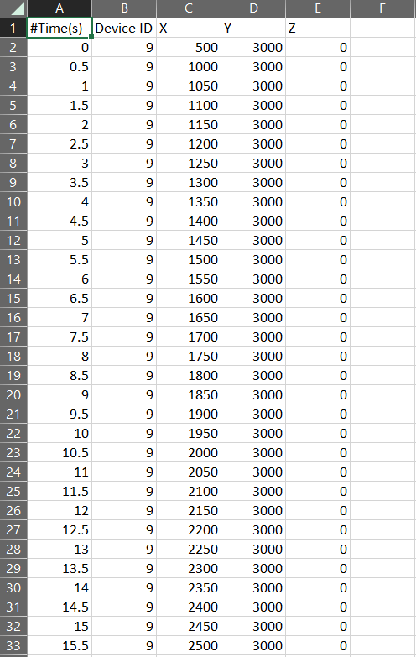 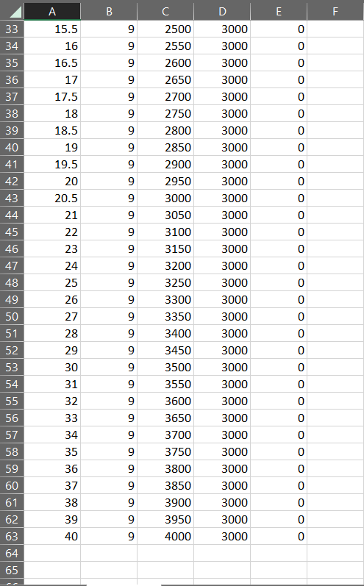

Fig: 1-2a. Mobility file sample

**Step 8:** Packet Trace is enabled in NetSim GUI. At the end of the simulation, a very large .csv file containing all the packet information is available for the users to perform packet level analysis. Plots is enabled in NetSim GUI.

**Step 9:** The log file can enable per the information provided in **Section 3.22** 5G-NR technology library document.

**Step 10:** Run the simulation for 50 seconds.

### Results and Discussion

#### Handover Signaling



Figure 0‑3: Control packet flow in the 5G handover process

The packet flow depicted above can be observed from the packet trace.

1. UE will send the UE_MEASUREMENT_REPORT every 120 ms to the connected gNB
2. The initial UE-gNB connection and UE association with the core takes place by transferring the RRC and Registration, session request response packets.
3. As per the configured file-based mobility, UE 9 moves towards gNB 8.
4. After 18.6 s gNB 7sends the HANDOVER REQUEST to gNB 8.
5. gNB 8 sends back HANDOVER REQUEST ACK to gNB 7.
6. After receiving HANDOVER REQUEST ACK from gNB 8, gNB 7 sends the HANDOVER COMMAND to UE 9.
7. After the HANDOVER COMMAND packet is transferred to the UE, the target gNB will send the PATH SWITCH packet to the AMF via Switch 5.
8. When the AMF receives the PATH SWITCH packet, it sends MODIFY BEARER REQUEST to the SMF.
9. The SMF, on receiving the MODIFY BEARER REQUEST, provides an acknowledgement to the AMF.
10. On receiving the MODIFY BEARER RESPONSE from the SMF, AMF acknowledges the Path switch request sent by the target gNB by sending the PATH SWITCH ACK packet back to the target gNB via Switch 5.
11. The target gNB sends CONTEXT RELEASE to source gNB, and the source gNB sends back CONTEXT RELEASE ACK to target gNB. The context release request and ack packets are sent between the source and target gNB via Switch 6.
12. RRC Reconfiguration will take place between target gNB and UE 9.
13. The UE 9 will now start sending the UE MEASUREMENT REPORT to gNB 8.

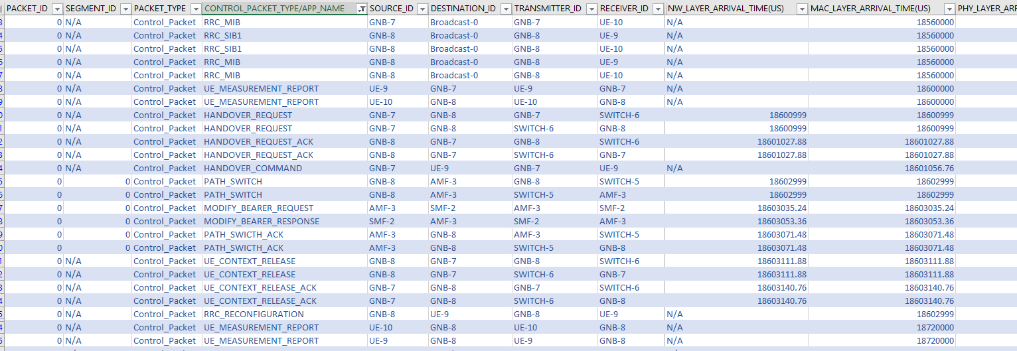

Figure 0‑4: Screenshot of NetSim packet trace file showing the control packets involved in handover. Some columns have been hidden before the last column.

#### Plot of SNR vs. Time

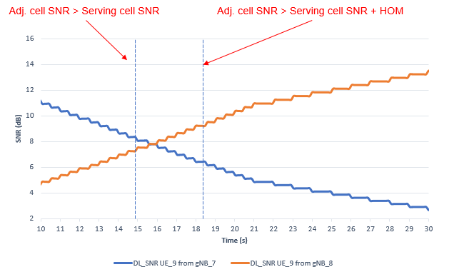

Figure 0‑5: Plot of DL SNR (at UE_3 from gNB1 and gNB2) vs time. The handover process shown in Figure 0‑3 commences when Adj_cell_SNR > Serving_cell_SNR + Hand_over_Margin

This plot can be got from the LTENRLog file. However, it would involve a fair amount of time and effort. You can open the log file and see the values, instead of plotting. (You can obtain the values using Pivot tables, and the previous experiments contains the information required to work with pivot tables.)

* Time 15.60s, the SNR from gNB7 is 7.81dB and the SNR from gNB8 is also 7.81dB. This represents the point where the two curves intersect.
* Time 18.6s, the SNR from gNB7 is 6.18 dB and the SNR from gNB8 is 9.51dB. This represents the point where Adj cell RSRP is greater than serving cell RSRP by the Hand-over-margin (HOM) of 3 dB.

## PART II: THROUGHPUT AND DELAY VARIATION DURING HANDOVER

First, open the relevant configuration file by selecting: **Experiments> 5G NR> Handover in 5GNR> Throughput and delay variation during handover** > **Effect of handover on Delay and Throughput.** See figure below:

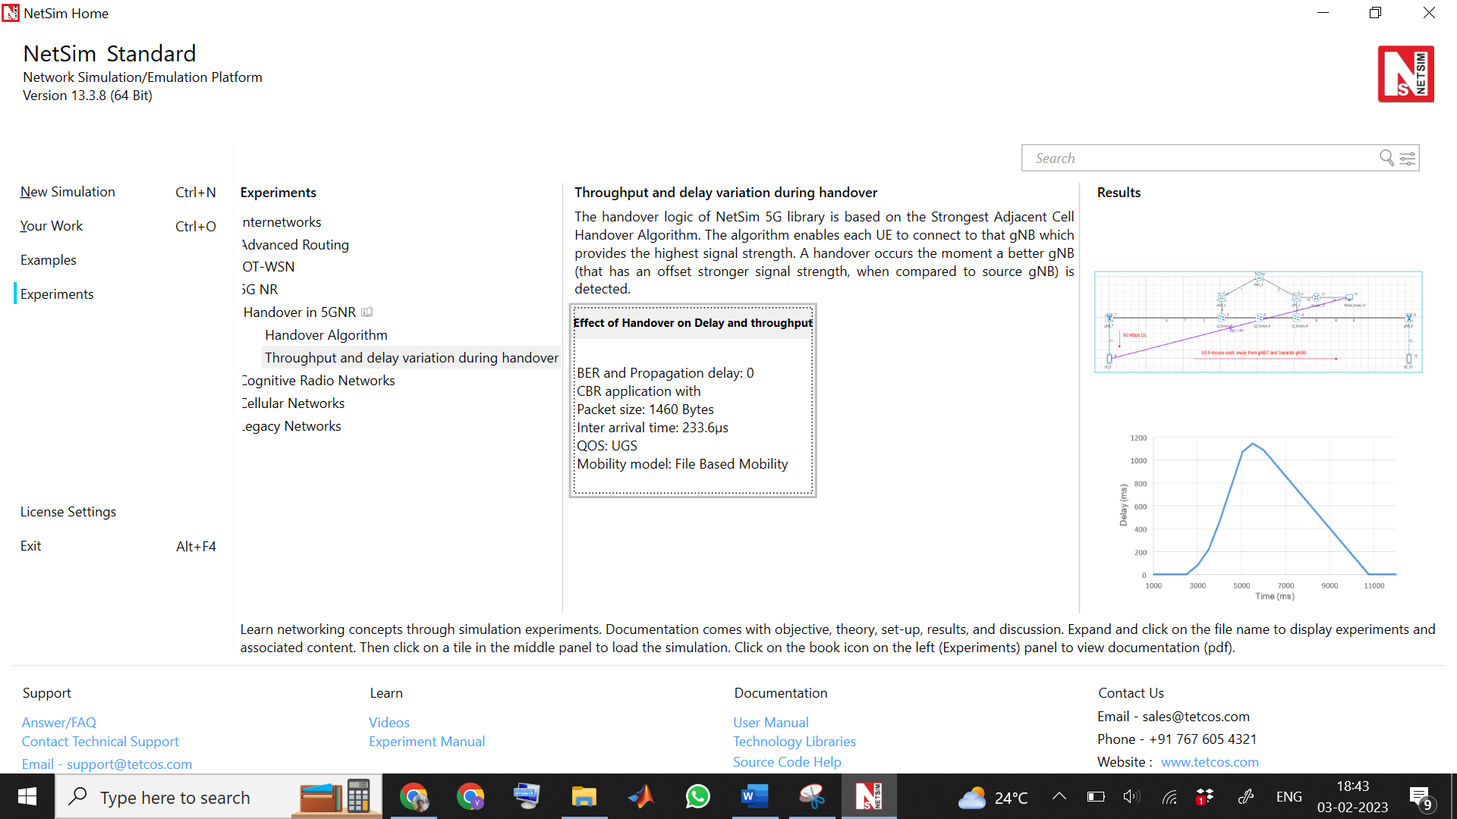

NetSim UI displays the configuration file corresponding to this experiment as shown below Figure 0‑6.

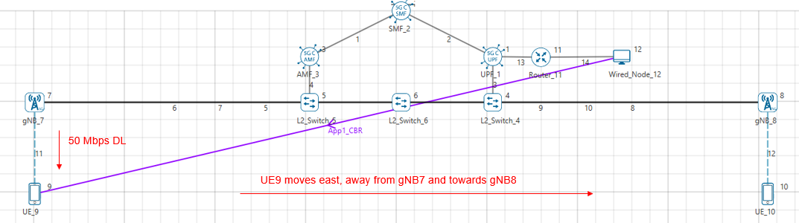

Figure 0‑6a: Network set up for studying the throughput and delay variation during handover

### Procedure for Effect of Handover on Delay and Throughput

The following set of procedures were done to generate this sample:

**Step 1:** A network scenario is designed in NetSim GUI comprising of 2 gNBs, 5G Core, 1 Router, 1 Wired Node and 2 UEs in the **“5G NR”** Network Library.

**Step 2:** The device positions are set as per the table given in Table 0‑3.

|  |  |  |  |  |
| --- | --- | --- | --- | --- |
|  | gNB 7 | gNB 8 | UE 9 | UE 10 |
| X Co-ordinate | 500 | 4500 | 500 | 4500 |
| Y Co-ordinate | 500 | 500 | 1000 | 1000 |

Table 0‑3: Device positions.

**Step 3:** Right click on the gNB 7 and select Properties and set the following.

|  |  |
| --- | --- |
| Interface(5G_RAN) Properties |  |
| CA_Type | Single Band |
| CA_Configuration | n78 |
| CA_Count | 1 |
| Numerology | 0 |
| Channel Bandwidth (MHz) | 10 |
| PRB Count | 52 |
| MCS Table | QAM64 |
| CQI Table | Table 1 |
| X_Overhead | XOH0 |
| DL UL Ratio | 4:1 |
| Pathloss Model | 3GPPTR38.901-7.4.1 |
| Outdoor Scenario | Urban Macro |
| LOS_NLOS Selection | User_Defined |
| LOS Probability | 1 |
| Shadow Fading Model | None |
| Fading _and_Beamforming | NO_FADING_MIMO_UNIT_GAIN |
| Additional Loss Model | None |

Table 0‑4: gNB _7> Interface(5G_RAN) Properties Setting.

Similarly, it is set for gNB 8.

**Step 4:** The Tx_Antenna_Count was set to 2 and Rx_Antenna_Count was set to 1 in gNB > Interface (5G_RAN) > Physical Layer.

**Step 5:** The Tx_Antenna_Count was set to 1 and Rx_Antenna_Count was set to 2 in UE > Interface (5G_RAN) > Physical Layer.

**Step 6:** In the General Properties of UE 9 and UE 10, set Mobility Model as File Based Mobility.

**Step 7:** The BER and propagation delay was set to zero in all the wired links.

**Step 8:** Right click on the Application Flow **App1 CBR** and select Properties or click on the Application icon present in the top ribbon/toolbar.

A CBR Application is generated from Wired Node 12 i.e., Source to UE 9 i.e., Destination, with Packet Size 1460 Bytes and Inter Arrival Time 233.6µs. QOS is set to UGS.

Additionally, the **“Start Time(s)”** parameter is set to 1, while configuring the application.

**File Based Mobility:**

In File Based Mobility, users can write their own custom mobility models and define the movement of the mobile users. Create a mobility.txt file for UE’s involved in mobility with each step equal to 0.5 sec with distance 50 m.

The NetSim Mobility File (mobility.txt) looks like the following figure:

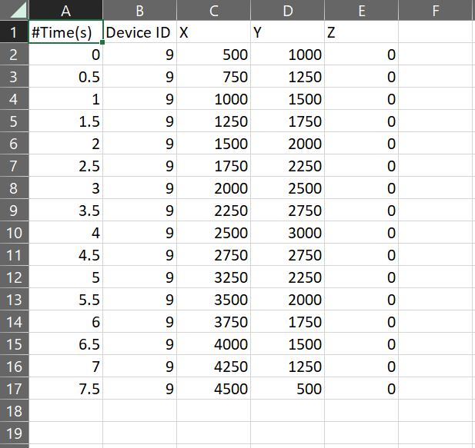

Fig 1-6(b) Mobility file sample

**Step 9:** Packet Trace and Event Trace is enabled in NetSim GUI. At the end of the simulation, a very large .csv file containing all the packet information is available for the users to perform packet level analysis. Plots is enabled in NetSim GUI.

**Step 10:** The log file is populated as per the information provided in **Section 3.22** 5G NR technology library document.

**Step 11:** Run the simulation for 20 seconds.

### Computing the delay and throughput

#### Delay computation from Event Traces

***NOTE:******Follow the article link given below, to generate pivot table for large Packet Trace and Event Trace files***

[*How to generate pivot reports for large packet trace and event trace files?*](https://support.tetcos.com/en/support/solutions/articles/14000122911-how-to-generate-pivot-reports-for-large-packet-trace-and-event-trace-files-)

1. Open Event Trace after simulation.
2. Go to **Insert** option at the top ribbon of the trace window and select **Pivot Tables**.
3. In the window which arises, you can see **Table_1**. Click on OK.
4. This will create a new sheet with Pivot Table as shown in Figure 0‑7.

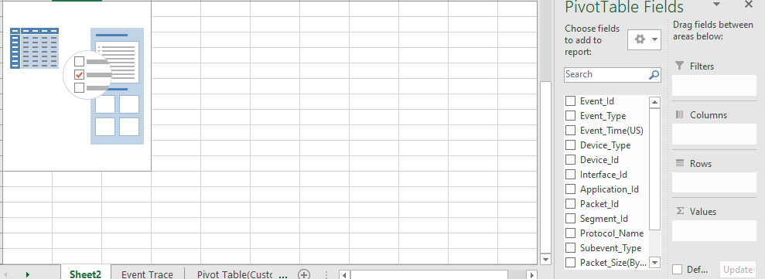

Figure 0‑7: Blank Pivot Table

1. Now drag and drop **Packet_Id** to **Rows** field. Similarly, drag and drop the following: **Event_Type** to **Columns** field, **Event_Time** to **Values** field, as shown Figure 0‑8.

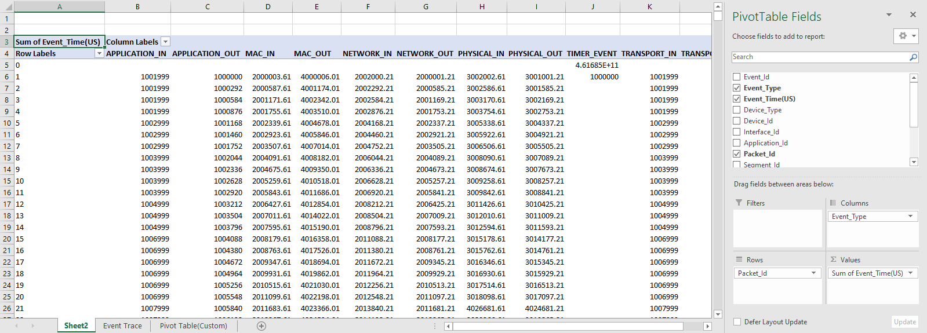

Figure 0‑8: Adding fields into Columns, Rows and Values

1. Now, in the Pivot table formed, filter **Event_Type** to **APPLICATION_IN** and **APPLICATION_OUT** as shown in Figure 0‑9.

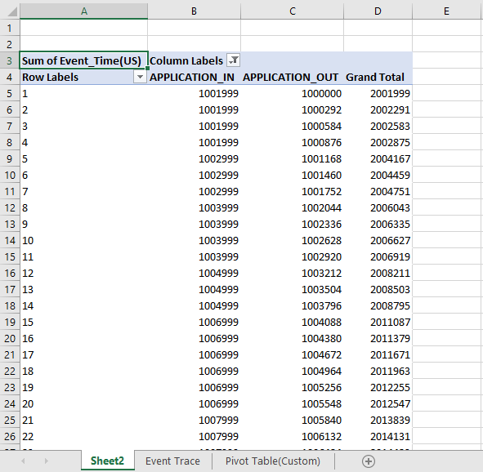

Figure 0‑9: Event Type filtered to APPLICATION_IN and APPLICATION_OUT to calculate delay.

1. In the **Values** field in the Pivot Table Fields, Click on **Sum of Event Time (US)** and select **Value Field Settings** as shown in Figure 0‑10.

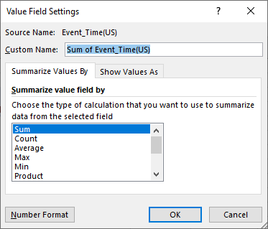

Figure 0‑10: Value Field Settings to Sum of Event Time

1. Select **Show Values As** option and filter it to **Difference From** as shown in Figure 0‑11.

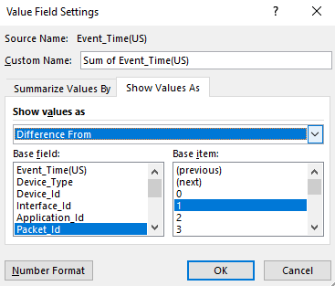

Figure 0‑11: Select Show Values as Difference From

1. In the **Base field**, select **Event_Type** and in the **Base_item** field select **APPLICATION_OUT** and click on OK. This will provide the end-to-end delay in the pivot table.

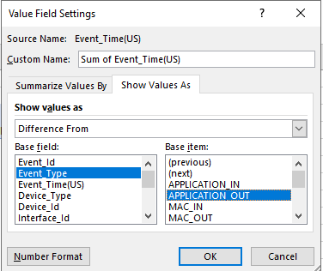

Figure 0‑12: Select Base field to Event Type and Base item to APPLICATION OUT

1. Now ignore the negative readings in the Delay values (Figure 0‑13) obtained and use these values to plot the Delay vs Time (APPLICATION_IN) graph.

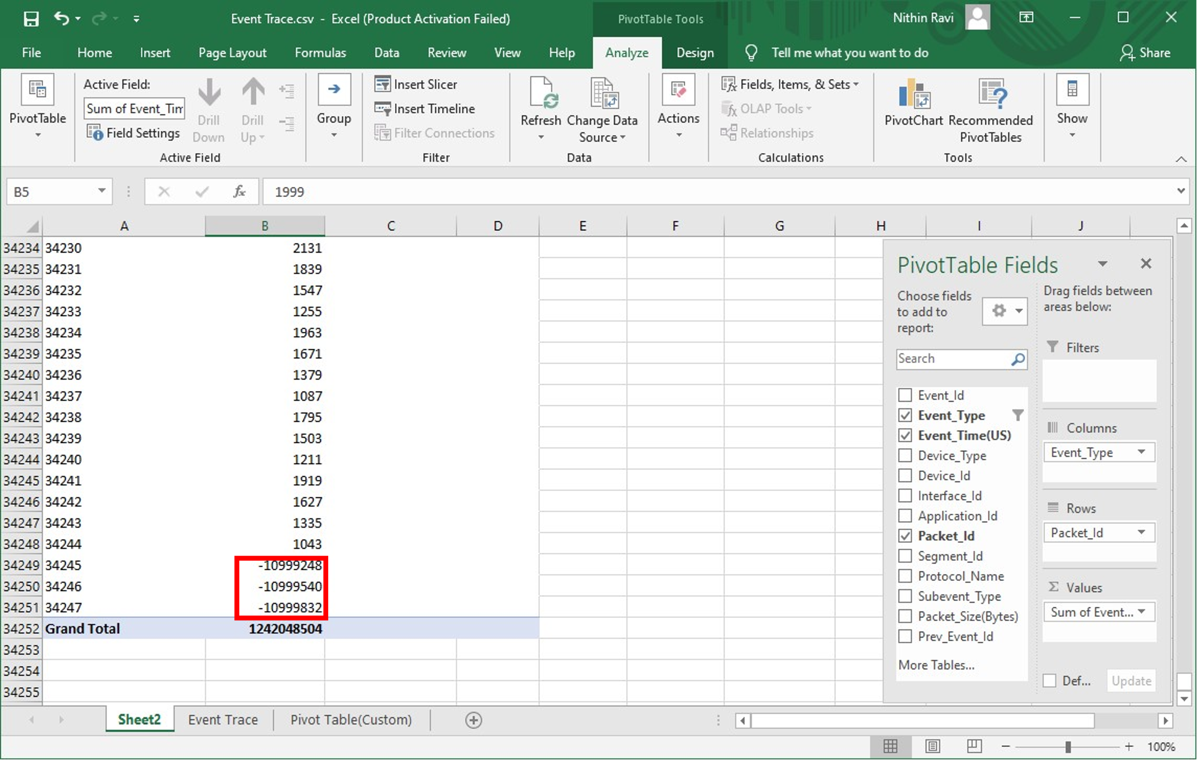

Figure 0‑13: Ignore the negative values in the Delay

1. In the Event trace window, filter the **Event Type** to **APPLICATION_IN** and use the Event Time thus obtained as the x-axis of the plot.

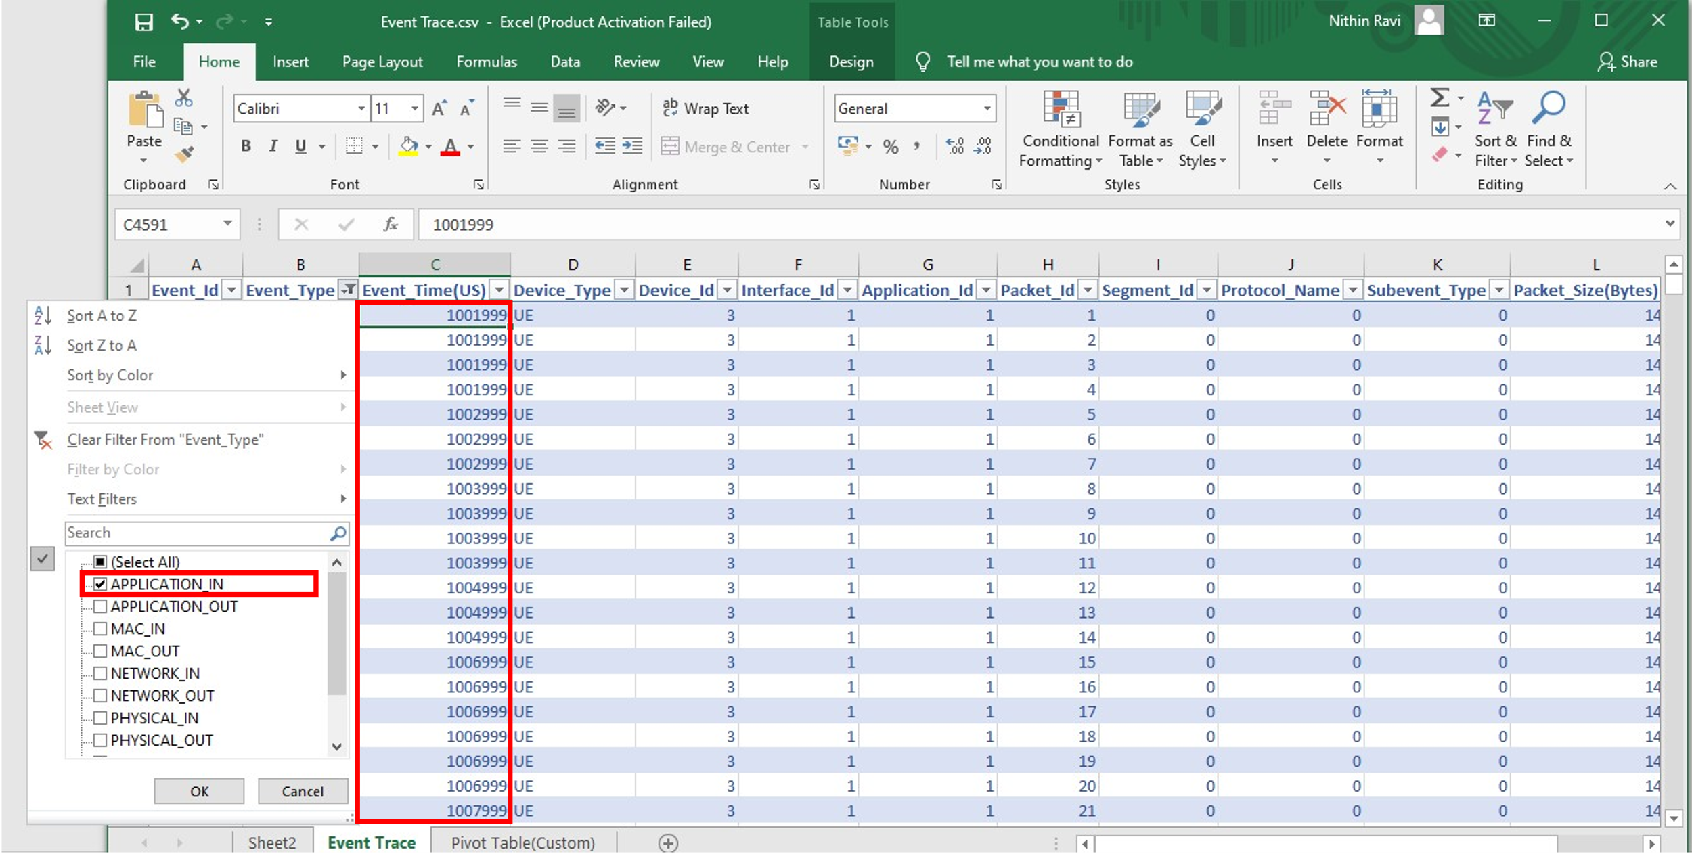

Figure 0‑14: Event Trace

### Results and Discussion

**UDP Throughput Plot**

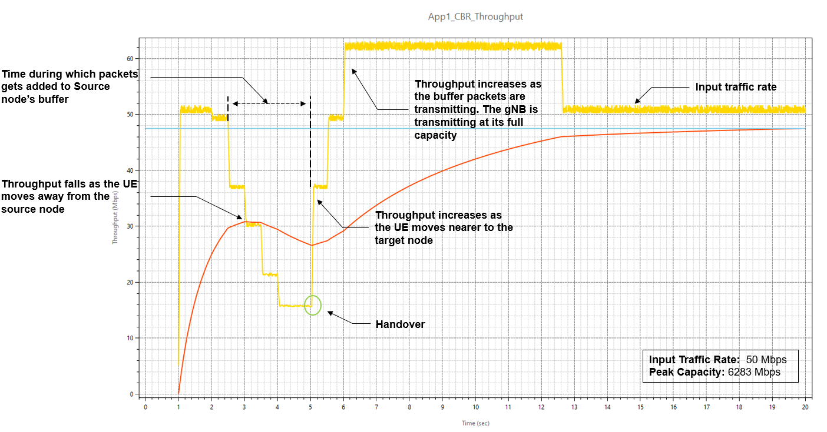

Figure 0‑15: We see how throughput varies with time, and the reasons for this variation, as the UE moves from the source gNB to the target gNB. Note that there is a slight typo in the legend. The peak capacity is 62.83 Mbps, not 6383 Mbps.

The application starts at 1s. The packet generation rate is 50 Mbps and we see the network is able to handle this load, and the throughput is equal to the generation rate. We then observe that the throughput starts dropping from 2.5s onwards because the UE is moving away from the gNB. As it moves, the SNR falls, and therefore a lower MCS is chosen, leading to reduced throughput. At 3 s there is a further drop in throughput and then a final dip at 3.9 s. The time the handover occurs is 5.04 s. At this point we see the throughput starts increasing once UE attaches to gNB8. For a short period of time, the throughput is greater than 50 Mbps because of the transmission of queued packets in the s-gNB buffer which get transferred to the t-gNB buffer over the Xn interface.

**UDP Delay Plot**

Figure 0‑16: Plot of Delay vs. Time

Since the application starts at 1 s, the UDP plot begins at 1000 ms. The initial UDP delay is $≈1 ms$, and hence the curve is seen as close to 0 on the Y axis. We then see that the packet delay starts increasing as the UE moves away from the gNB. This is because the link capacity drops as the CQI falls. The peak delay experienced shoots up to $≈$ 1.1 s at $≈$ 5.5 s when the handover occurs. Once the handover is complete the delay starts reducing and returns to $≈1 ms$. The reason is that as the UE moves closer to the gNB its CQI increases and hence the 5G link can transmit at a higher rate (see Figure 0‑15).

Please see the next page for your exercises.

**YOUR EXERCISES:**

**Let the last digit of your trainee ID be x. Then set the transmit power at the BS to (30 + 2*x) dBm at both the gNBs.**

1. **Repeat the above experiment for your value of transmit power by replicating Fig. 1-5, 1-15, 1-16. Infer and justify all your results.**
2. **In this exercise, we will understand the effect of handover margin on the process of handover. To change the handover margin, do the following steps.**

**gNB Properties > Interface_4 (5G_RAN) > DATALINK_LAYER > HANDOVER > Handover Margin (dB)**

**If x is odd, replicate figures 1-5, 1-15, 1-16 for two handover margins: 1 dB and 9 dB, with your customized gNB transmit powers.**

**If x is even, replicate figures 1-5, 1-15, 1-16 for two handover margins: 2 dB and 10 dB, with your customized gNB transmit powers.**

**Infer and justify your observations on how the handover margin affects the process of handover in terms of points of handover, delay and throughput of the application.**

1. K. Dimou et al., "Handover within 3GPP LTE: Design Principles and Performance," 2009 IEEE 70th Vehicular Technology Conference Fall, Anchorage, AK, USA, 2009, pp. 1-5.